ECE421 Assignment 3: Unsupervised Learning and Probabilistic Models

Alexander APOSTOLOV (1005644279) and Anthony KEMMEUGNE (1004686789)

Participation percentage 50%-50%

# 1. K-Means

## 1.1 Learning K-means

1.1.1

For K = 3



We remarked that the loss is decreasing exponentially and converged within a few hundred updates (less than 300 hundred).

1.1.2

We plotted the 2D scatter data points colored by their cluster assignments as wells as the percentage of data belonging to each of the cluster K, with K = 1,2,3,4,5:

For K = 1



100 % of points belongs to the class K = 1

For K = 2



0.5046% of points belongs to the class K = 1

0.4954% of points belongs to the class K = 2

For K = 3



0.3813% of points belongs to the class K = 1

0.2381% of points belongs to the class K = 2

0.3806% of points belongs to the class K = 3

For K = 4



0.121% of points belongs to the class K = 1

0.1349% of points belongs to the class K = 2

0.3713% of points belongs to the class K = 3

0.3728% of points belongs to the class K = 4

For K = 5





0.3576% of points belongs to the class K = 1

0.0842% of points belongs to the class K = 2

0.3624% of points belongs to the class K = 3

0.1077% of points belongs to the class K = 4

0.0881% of points belongs to the class K = 5

According to the 2D scatter plot of the data we concluded that 3 clusters is the best to classify the data set. We can clearly see that there are 3 zones on the scatter and using more than 3 classes just divides the middle one in other classes which should not exist in the first place.

1.1.3

We hold 1/3 of data for validation and computed the loss for different values of K :

|  |  |
| --- | --- |
| ***Number of clusters K*** | ***Validation Loss*** |
| 1 | 12870.106 |
| 2 | 2960.6724 |
| 3 | 1629.2081 |
| 4 | 1054.4578 |
| 5 | 901.00555 |

According to the loss on the validation set we can deduce that the best number of clusters will be 5. Indeed, the loss decreases as the number of cluster increases. That can be explained because for K >3 the center of the clusters will be located in the middle of the data set. Therefore, since the loss is the minimization of the distance between a point and the center of a cluster. Increasing the number of clusters will lead to the decrease of the error. Therefore, the limitation of the K-means algorithm is that it can be difficult to identify the proper number of classes.

# 2. Mixtures of Gaussians

## 2.1 The Gaussian cluster mode

### 2.1.1

Here is a snippet of the Python code to compute the log probability density for cluster k:

$logN(x;μ^{k}, σ^{k^{2}})$

Where $N(x;μ, Σ)$ is equivalent to:



for all pair of N data points and K clusters we obtain the following function:

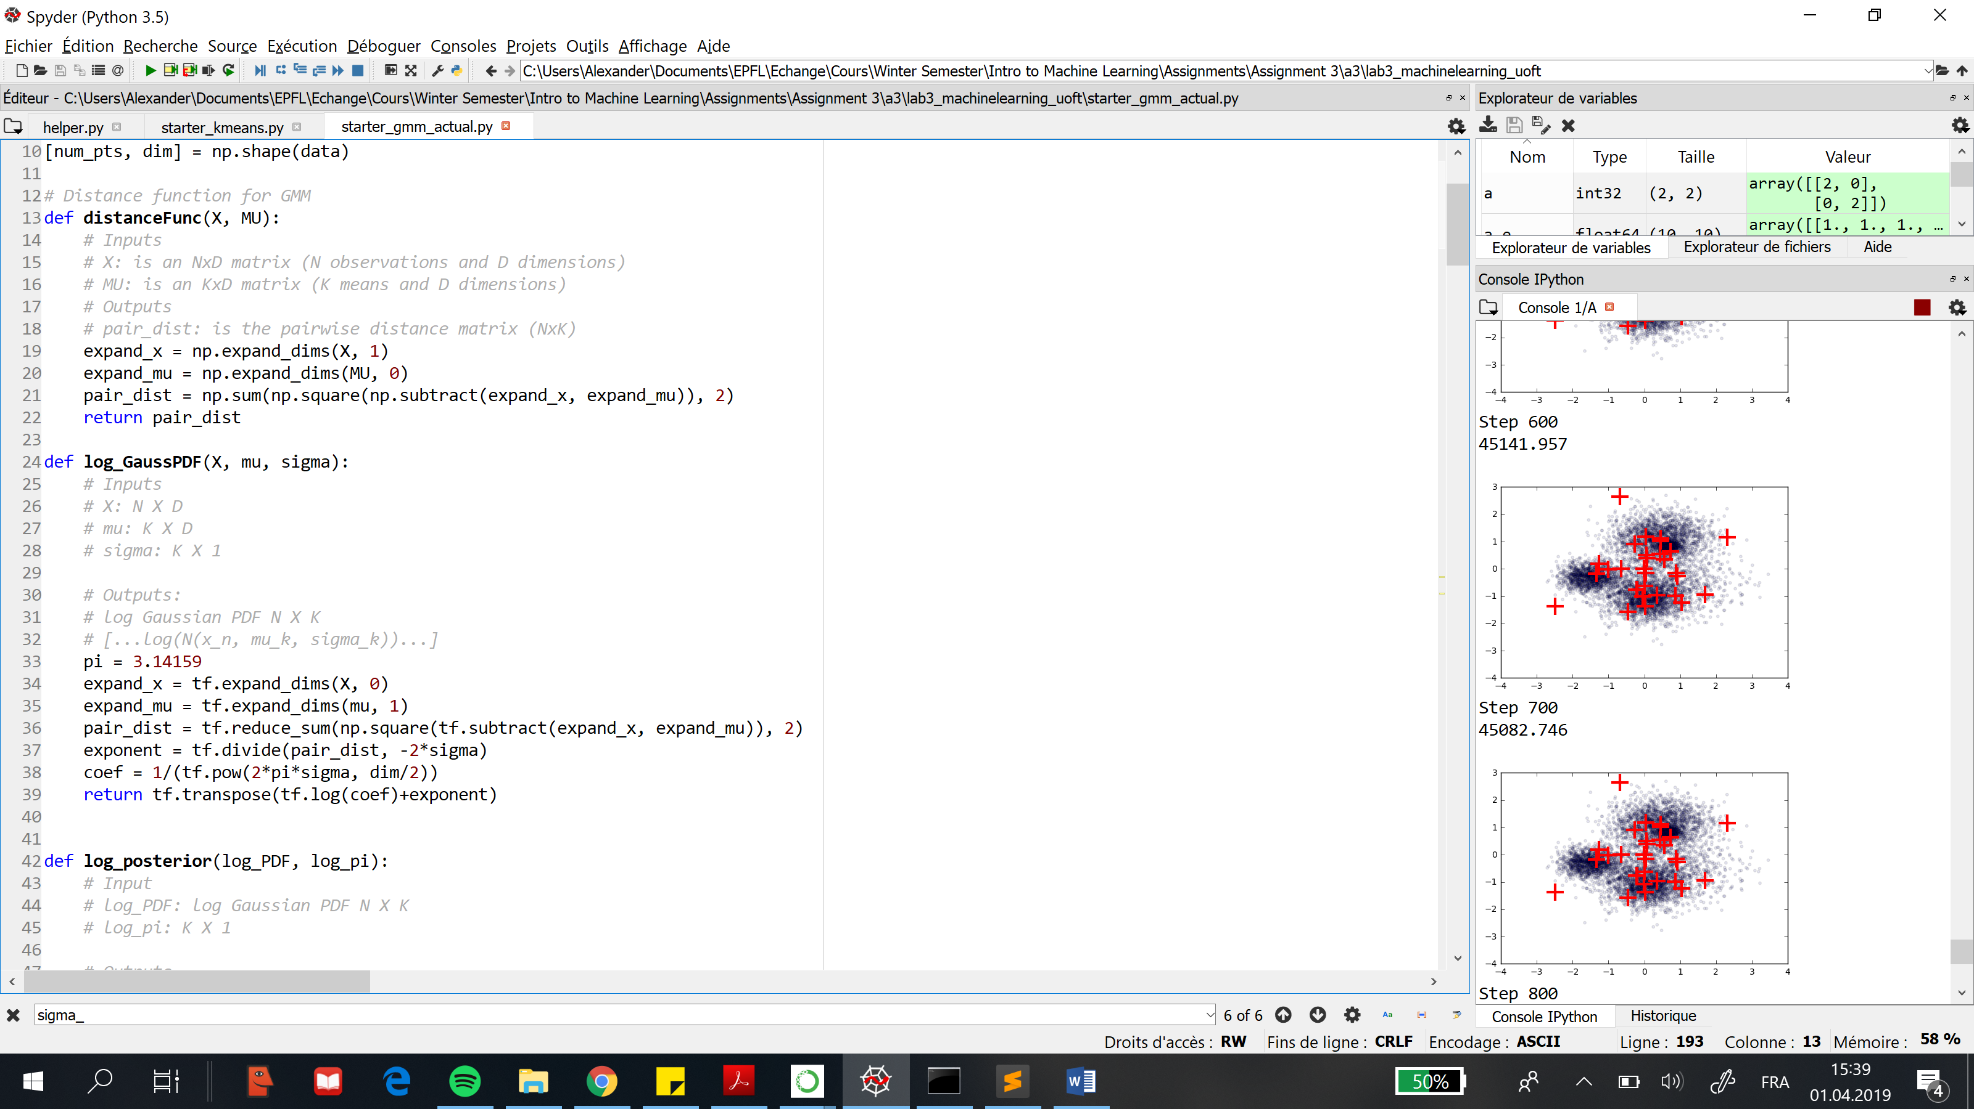

### 2.1.2

Here is a snippet of the Python code for the vectorized Tensorow function that computes the log probability of the cluster variable z given the data vector x: $\log{P \left(z \right| \underline{x})}$:

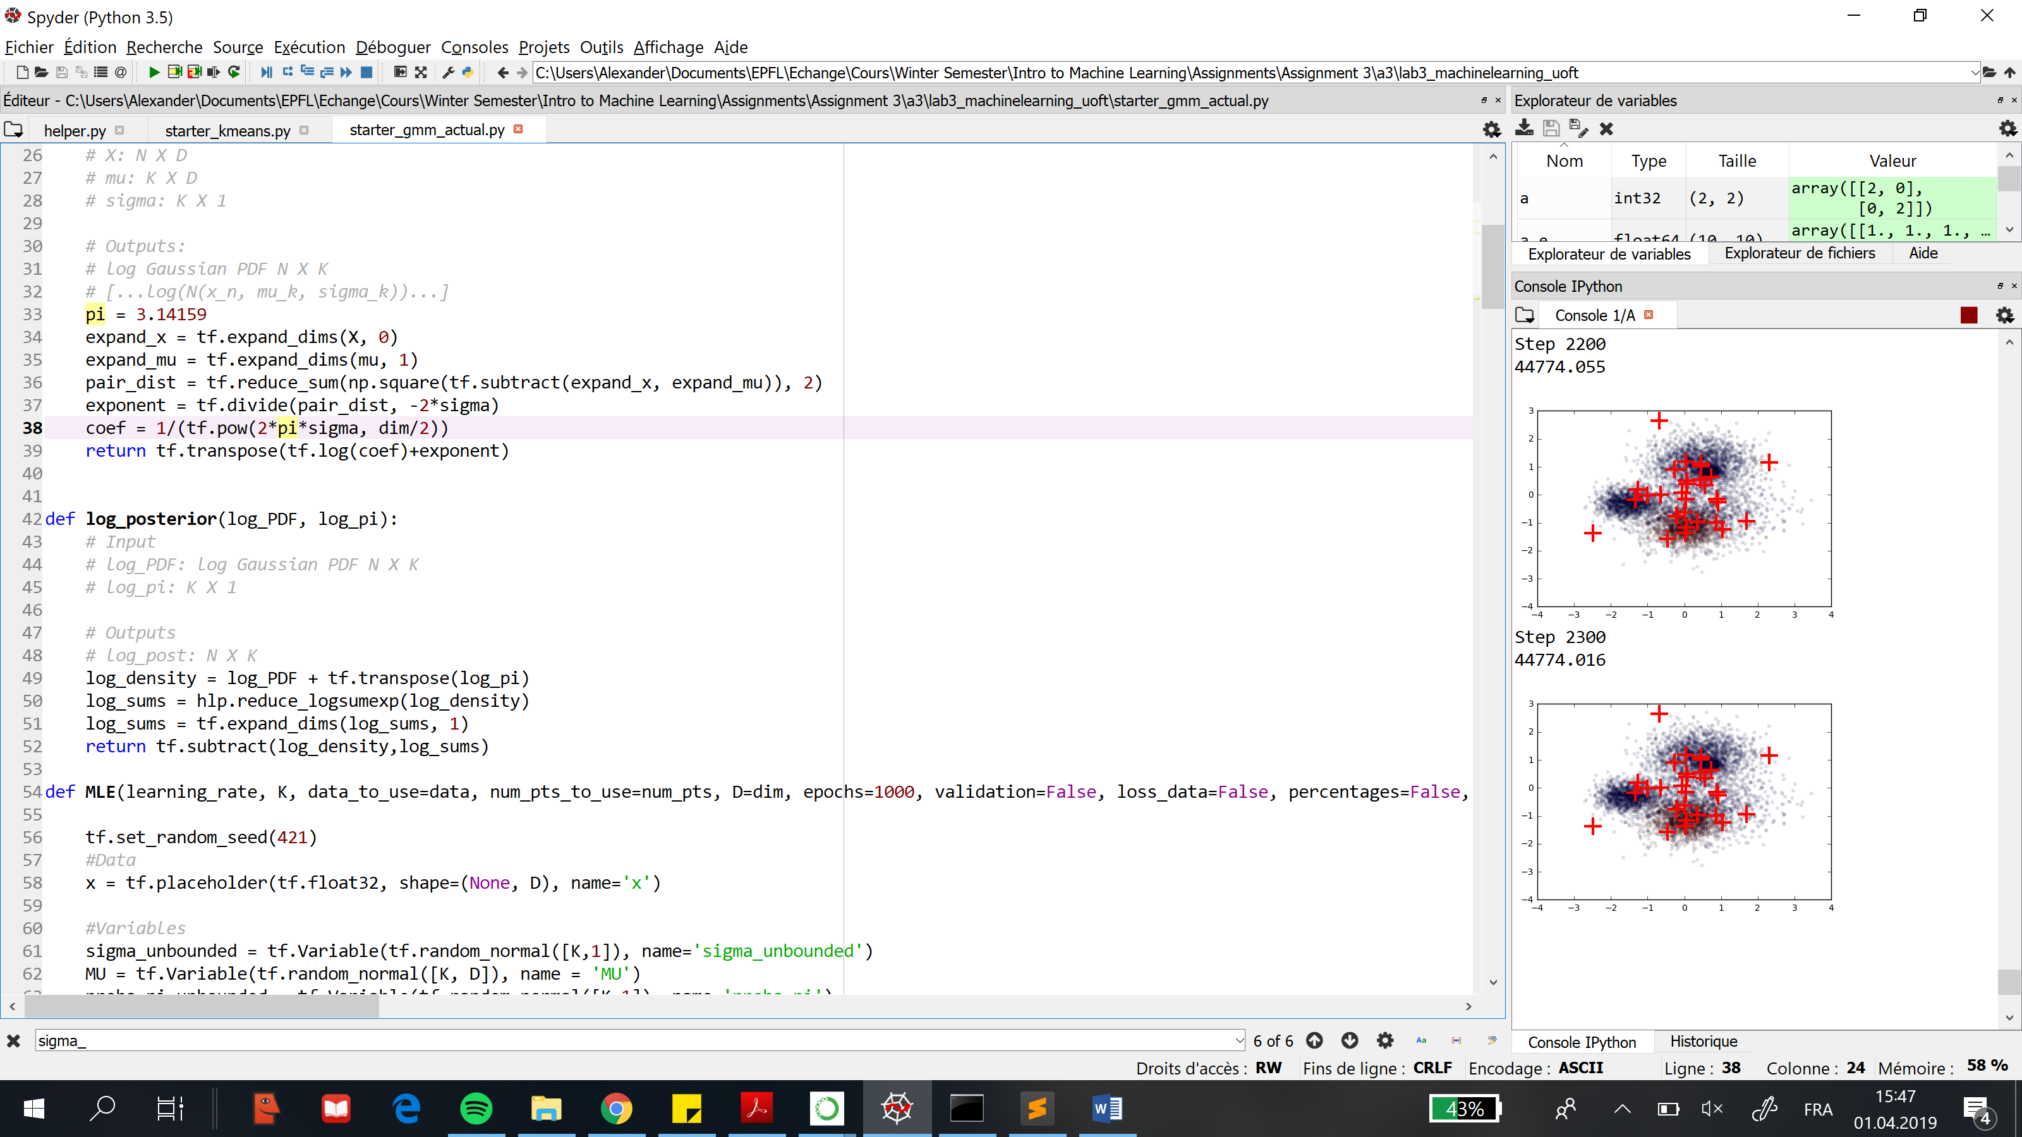

It is important here to use the function log-sum-exp instead of tf.reduce_sum because the result would be different. Indeed, what we want in the end is the logarithm of the sum of the probabilities, so, to get this, we can’t just sum the logs of the different probabilities because the log of a sum is not equal to the sum of the logs. The functions log-sum-exp takes as input the matrix with the log of the densities (part 2.1.1) and first takes the exp of every value to get the actual probabilities, then sums them across each line and finally takes the log of the sums and this is what we want.

## 2.2 Learning the MoG

### 2.2.1

For the dataset data2D.npy, we have set K = 3 and here are the best model parameters the model has learnt:

|  |  |  |  |
| --- | --- | --- | --- |
| **Variable** | **K1** | **K2** | **K3** |
| MU (1st dimension) | 1.2983317 | 0.10594884 | -1.101704 |
| MU (2nd dimension) | 0.30934337 | -1.5274277 | -3.3058665 |
| Sigma | 0.03885003 | 0.9871935 | 0.03908059 |
| PI | 0.33344018 | 0.33464858 | 0.33191118 |

Here is a plot of the loss vs the number of updates:

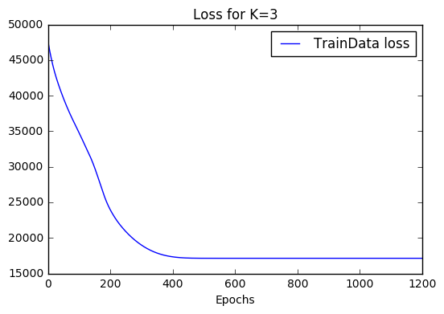

We see here as well that the loss is decreasing almost exponentially and it converges within a few hundred updates (less than 300). So, we can say that both algorithms converge with roughly the same speed.

### 2.2.2

We have trained our model with 2/3 of the data and kept the last third for validation purposes. Here are the final validation losses for the different values of K:

|  |  |
| --- | --- |
| ***Number of clusters K*** | ***Validation loss*** |
| 1 | 11651.441 |
| 2 | 7987.7866 |
| 3 | 5629.6235 |
| 4 | 5632.228 |
| 5 | 5634.0493 |

According to the table above, we can conclude that we have the best clustering when K=3. Indeed, the loss is decreasing between K=1 and 3 and after the loss is roughly constant (it is even slightly increasing).

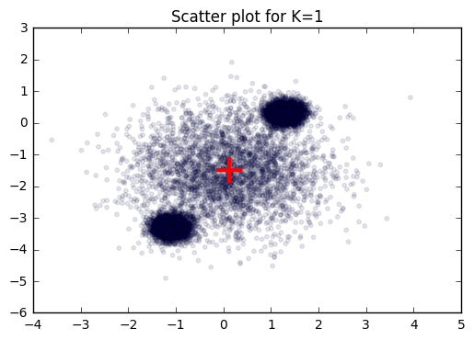Below are the scatter plots for values of K=1,2,3,4,5:

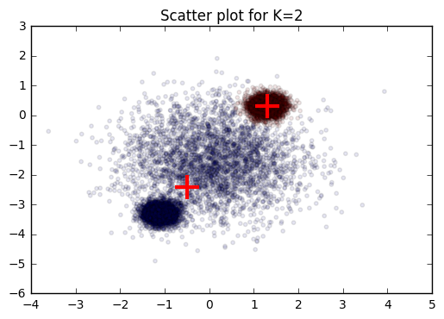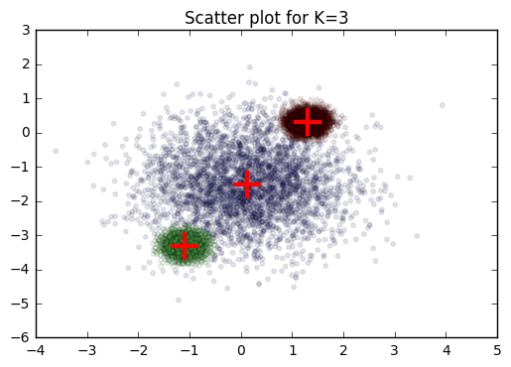

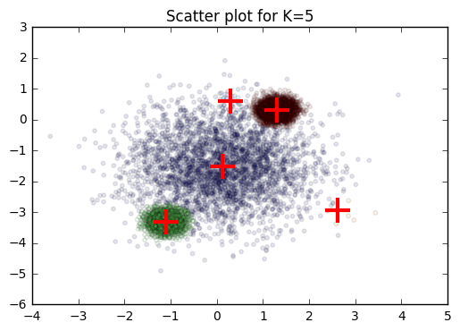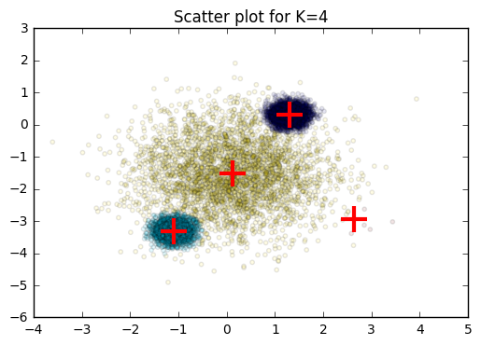

According to the scatter plots, we can also conclude that the best number of clusters is 3. Indeed, we see that after 3, the new clusters are just really small clusters on the edge of the image, which contain just a few points.

### 2.2.3

We ran the two algorithms on the set data100D.npy for K= {5, 10, 15, 20, 30} and here are the validation losses we had at the end of the learning process (we used 2/3 of the data for training and 1/3 for validation):

|  |  |  |
| --- | --- | --- |
| ***Number of clusters K*** | ***Validation loss with K-Means*** | ***Validation loss with MoG*** |
| 5 | 122’439.9 | 22’286.865 |
| 10 | 71’069.47 | 22’286.885 |
| 15 | 71’068.69 | 22’372.97 |
| 20 | 71’795.61 | 22’072.363 |
| 30 | 70’045.766 | 22’356.771 |

According to the validation losses for the MoG algorithm, we obtain that the smallest loss when K=20. However, we observed that the validation loss decreases as the number of cluster increase for the K-means algorithm. However, when we ran the K-means and MoG algorithm on the data2D.npy, we observed that the best way to get the appropriate number of clusters for a dataset is to use the MoG algorithm. Therefore, we can conclude that the best number of clusters is K =20.